# What is AI?

## II. Related fields

In addition to AI, there are several other closely related topics that are good to know at least by name. These include machine learning, data science, and deep learning.

Machine learning can be said to be a subfield of AI, which itself is a subfield of computer science. (Such categories are often somewhat imprecise and some parts of machine learning could be equally well or better belong to statistics.) Machine learning enables AI solutions that are adaptive. A concise definition can be given as follows:

## Key terminology

## Machine learning

Systems that improve their performance in a given task with more and more experience or data.

**Deep learning** is a subfield of machine learning, which itself is a subfield of AI, which itself is a subfield of computer science. We will meet deep learning in some more detail in Chapter 5, but for now let us just note that the “depth” of deep learning refers to the complexity of a mathematical model, and that the increased computing power of modern computers has allowed researchers to increase this complexity to reach levels that appear not only quantitatively but also qualitatively different from before. (As you notice, science often involves a number of progressively more special subfields, subfields of subfields, and so on. This enables researchers to zoom into a particular topic so that it is possible to catch up with the ever increasing amount of knowledge accrued over the years, and produce new knowledge on the topic — or sometimes, correct earlier knowledge to be more accurate.)

**Data science** is a recent umbrella term (term that covers several subdisciplines) that includes machine learning and statistics, certain aspects of computer science including algorithms, data storage, and web application development. Data science is also a practical discipline that requires understanding of the domain in which it is applied in, for example, business or science: its purpose (what "added value" means), basic assumptions, and constraints. Data science solutions often involve at least a pinch of AI (but usually not as much as one would expect from the headlines).

**Robotics** means building and programming robots so that they can operate in complex, real-world scenarios. In a way, robotics is the ultimate challenge of AI since it requires a combination of virtually all areas of AI. For example:

* Computer vision and speech recognition for sensing the environment
* Natural language processing, information retrieval, and reasoning under uncertainty for processing instructions and predicting consequences of potential actions
* Cognitive modeling and affective computing (systems that respond to expressions of human feelings or that mimic feelings) for interacting and working together with humans

Many of the robotics-related AI problems are best approached by machine learning, which makes machine learning a central branch of AI for robotics.

## Note

## What is a robot?

In brief, a robot is a machine comprising sensors (which sense the environment) and actuators (which act on the environment) that can be programmed to perform sequences of actions. People used to science-fictional depictions of robots will usually think of humanoid machines walking with an awkward gait and speaking in a metallic monotone. Most real-world robots currently in use look very different as they are designed according to the application. Most applications would not benefit from the robot having human shape, just like we don't have humanoid robots to do our dishwashing but machines in which we place the dishes to be washed by jets of water.  
  
It may not be obvious at first sight, but any kind of vehicles that have at least some level of autonomy and include sensors and actuators are also counted as robotics. On the other hand, only software based solutions such as customer service chatbot, even if they are sometimes called `software robots´ aren´t counted as (real) robotics.

**Answered**

**Exercise 2: Taxonomy of AI**

A taxonomy is a scheme for classifying many things that may be special cases of one another. We have explained the relationships between a number of disciplines or fields and pointed out, for example, that machine learning is usually considered to be a subfield of AI.

A convenient way to visualize a taxonomy is an Euler diagram. An Euler diagram (closely related to the more familiar Venn diagrams) consists of shapes that corresponds on concepts, which are organized so that overlap between the shapes corresponds to overlap between the concepts (see for example [Wikipedia: Euler Diagram](https://en.wikipedia.org/wiki/Euler_diagram)).

Notice that a taxonomy does not need to be strictly hierarchical. A discipline can be a subfield of more than one more general topic: for example, machine learning can also be thought to be a subfield of statistics. In this case, the subfield concept would be placed in the overlap between the more general topics.

Your task: Construct a taxonomy in the Euler diagram example given below showing the relationships between the following things: AI, machine learning, computer science, data science, and deep learning.

Where would you put AI?

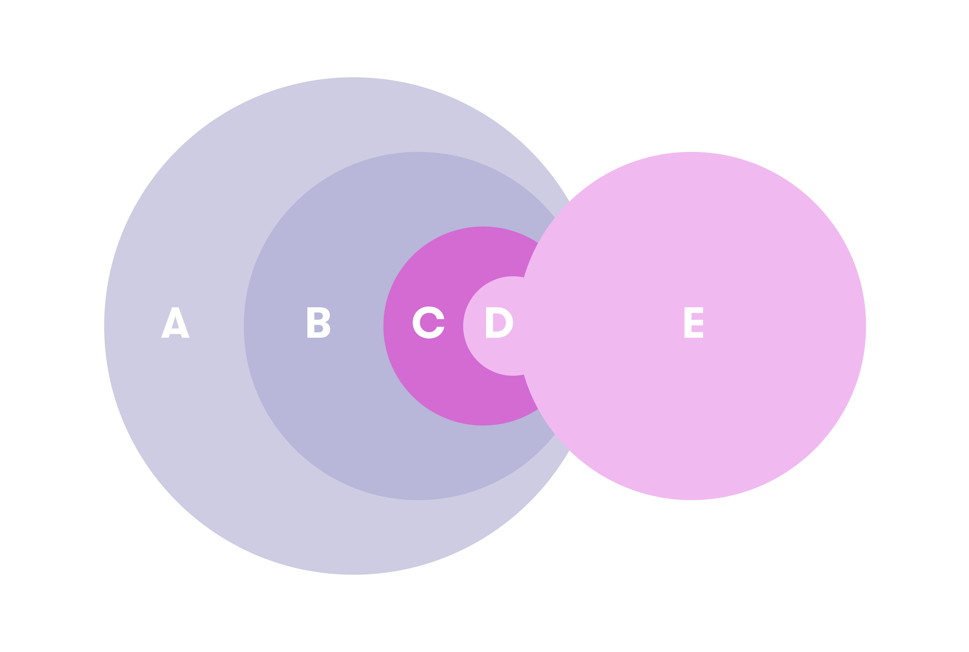

Section A

Section B

Section C

Section D

Section E

AI is a part of computer science.

Where would you put machine learning?

Section A

Section B

Section C

Section D

Section E

Machine learning is usually considered to be a part of AI.

Where would you put computer science?

Section A

Section B

Section C

Section D

Section E

Computer science is a relatively broad field that includes AI but also other subfields such as distributed computing, human-computer interaction, and software engineering.

Where would you put data science?

Section A

Section B

Section C

Section D

Section E

Data science needs computer science and AI. However, it also involves a lot of statistics, business, law, and other application domains, so it is usually not considered to be a part of computer science.

Where would you put deep learning?

Section A

Section B

Section C

Section D

Section E

Deep learning is a part of machine learning.

Your score:

**5/ 5**

**Answered**

**Exercise 3: Examples of tasks**

Consider the following example tasks. Try to determine which AI-related fields are involved in them. Select all that apply. (Hint: machine learning involves almost always some kind of statistics.)

Note: This exercise is meant to inspire you to think about the different aspects of AI and their role in various applications. As there are no clear-cut answers to many of these questions, this exercise will not be included in the grading. Nevertheless, we suggest that you do your best and try to answer as well as you can, but don't worry if our answers will differ from yours.

Autonomous car

Statistics

Robotics

Machine Learning

Autonomous cars apply a wide range of techniques to function. These include statistics, robotics, and machine learning.

Steering a rocket into orbit

Statistics

Robotics

Machine Learning

In order to steer a rocket into orbit robotics are needed to fire the engines at the right times and with the right power.

Online ad optimization

Statistics

Robotics

Machine Learning

In order to optimize ads online, machine learning and statistics are needed to deliver the correct type of ads to the right audience, and to measure the effectiveness of the optimization.

Customer service chatbot

Statistics

Robotics

Machine Learning

A customer service chatbot will need machine learning to process human produced language in such a way that it can act on it.

Summarizing gallup results

Statistics

Robotics

Machine Learning

Summarizing gallup results is a classical case of using statistics to produce insights.

Your score:

**2/ 5**